One Click PT Notes
User Guide
August 25, 2026

A walkthrough of patients, visits, clinical notes, weekly invoicing, and administration — with real screenshots from the application.

Contents

1. Getting Started

Logging in
Every user signs in with an email address and password (or a passkey, if one has been registered). What you see after logging in — which sections appear in the sidebar, and what you're allowed to create, edit, or delete — depends entirely on your assigned role.
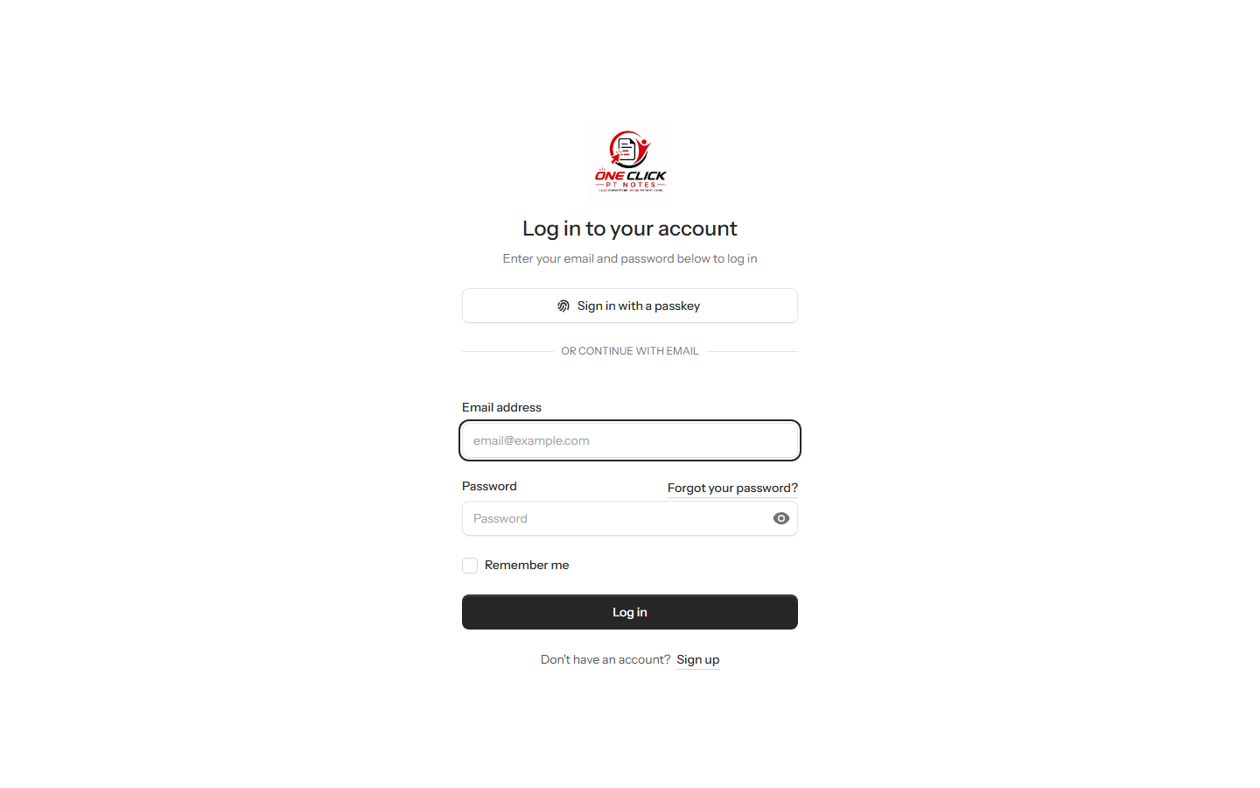
The login page.

The Dashboard
The dashboard is the home screen after login. It summarizes the patient roster (total, active, discharged, hospitalized) and your own activity for the day — visits today, upcoming visits, notes you've signed this week, and any unsigned drafts still waiting on you.
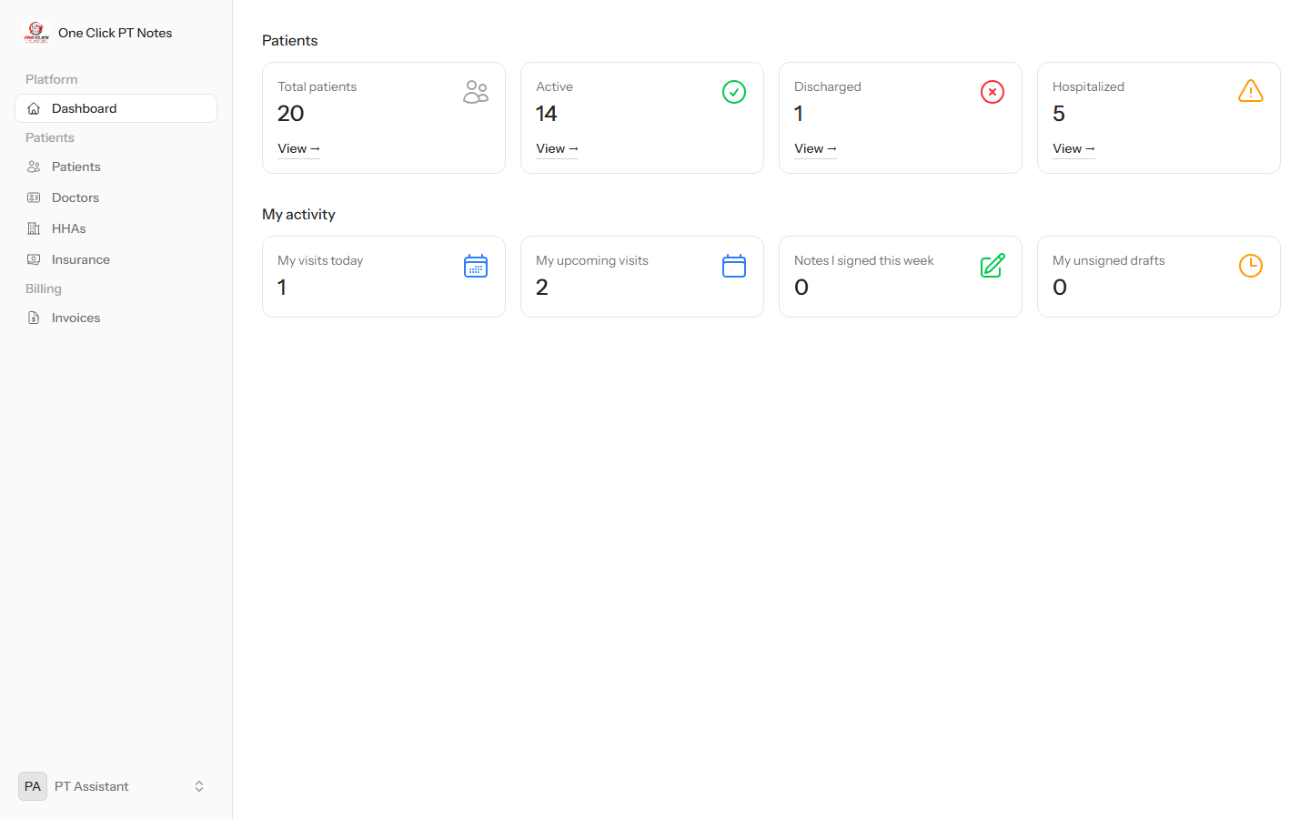
Dashboard, shown here for a PT Assistant.

The sidebar changes based on your role. A Billing section (Invoices) only appears for roles with billing permissions, and the Administration section only appears for admins. Everyone else sees just Patients and their reference lists (Doctors, HHAs, Insurance).

2. Managing Patients

The patient list
Patients → Patients lists everyone on service, searchable by name and filterable by status (Active / Discharged / Hospitalized). The PT Assistant column shows who is currently responsible for that patient's care.
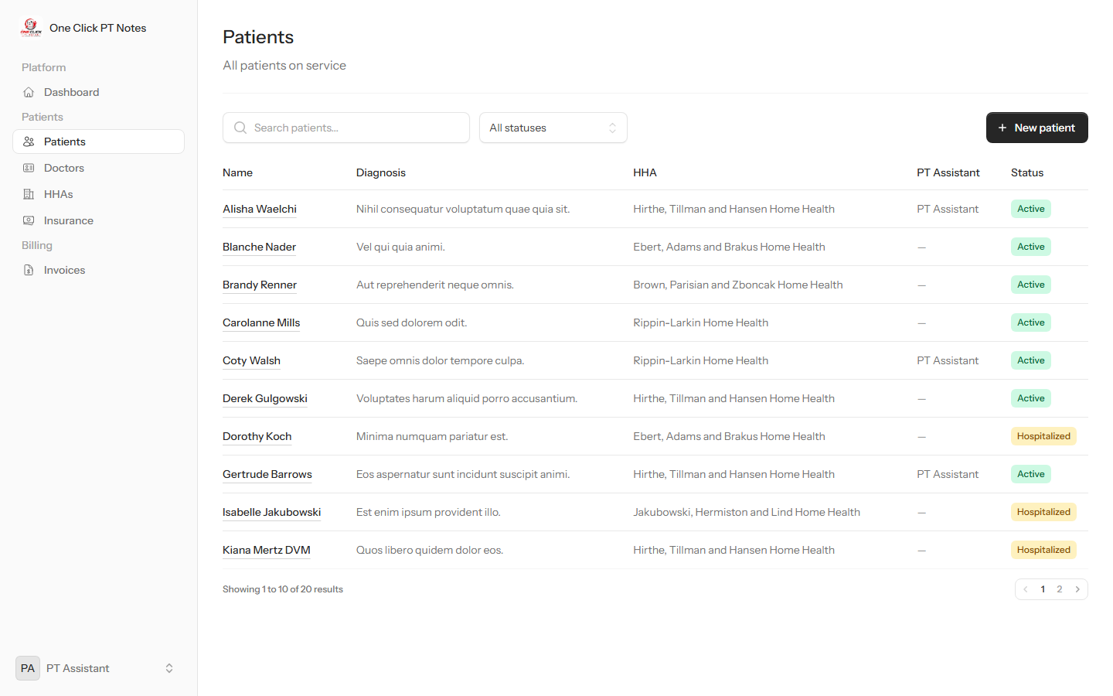
The patient roster.

Adding a new patient
“New patient” opens a form covering demographics, the care team (Doctor, Insurance, Home Health Agency, and PT Assistant), and status.
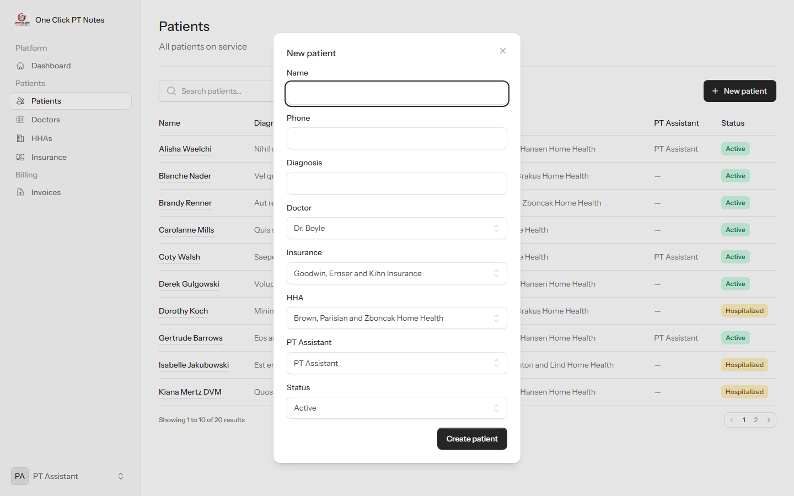
The New Patient form.

Who can do this: requires the patients.manage permission.

The patient detail page
Clicking a patient opens their full record: demographics, care team, treatment info (cert period, approved visits, PT frequency, etc.), their note history, and upcoming visits.
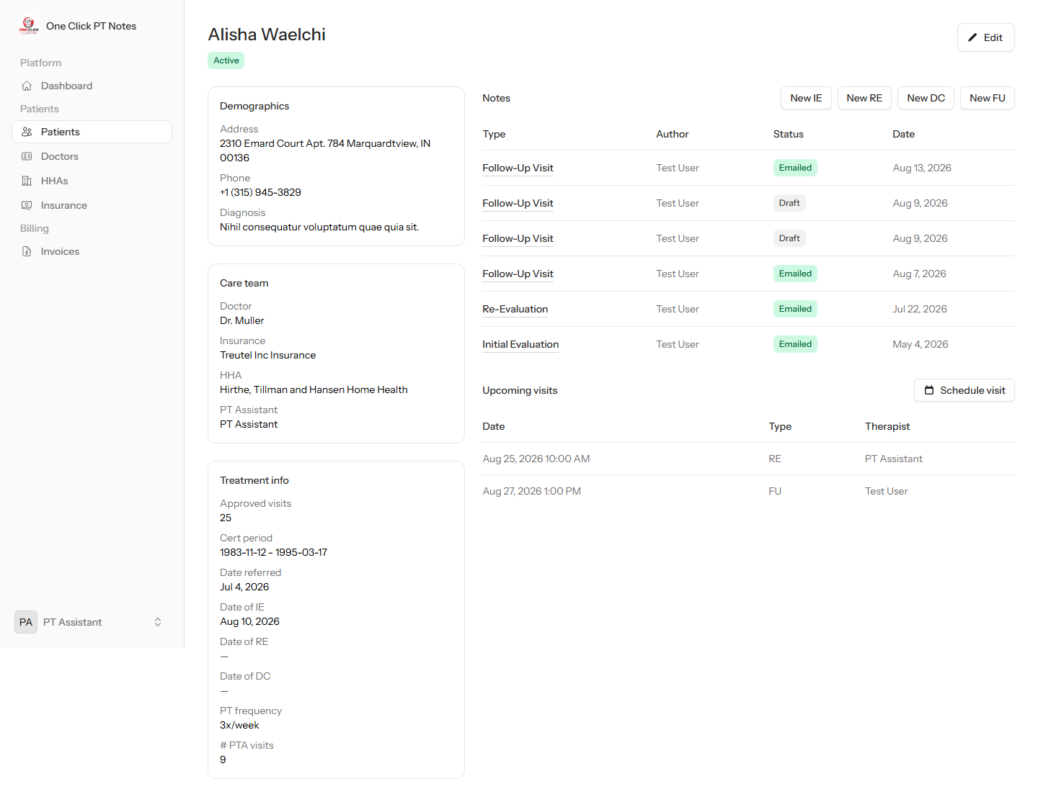
A patient's detail page.

Editing a patient / assigning a PT Assistant
“Edit” opens the same set of fields for updating. This is where a patient gets assigned to (or reassigned to a different) PT Assistant — the person responsible for their care, separate from who performs any one particular visit.
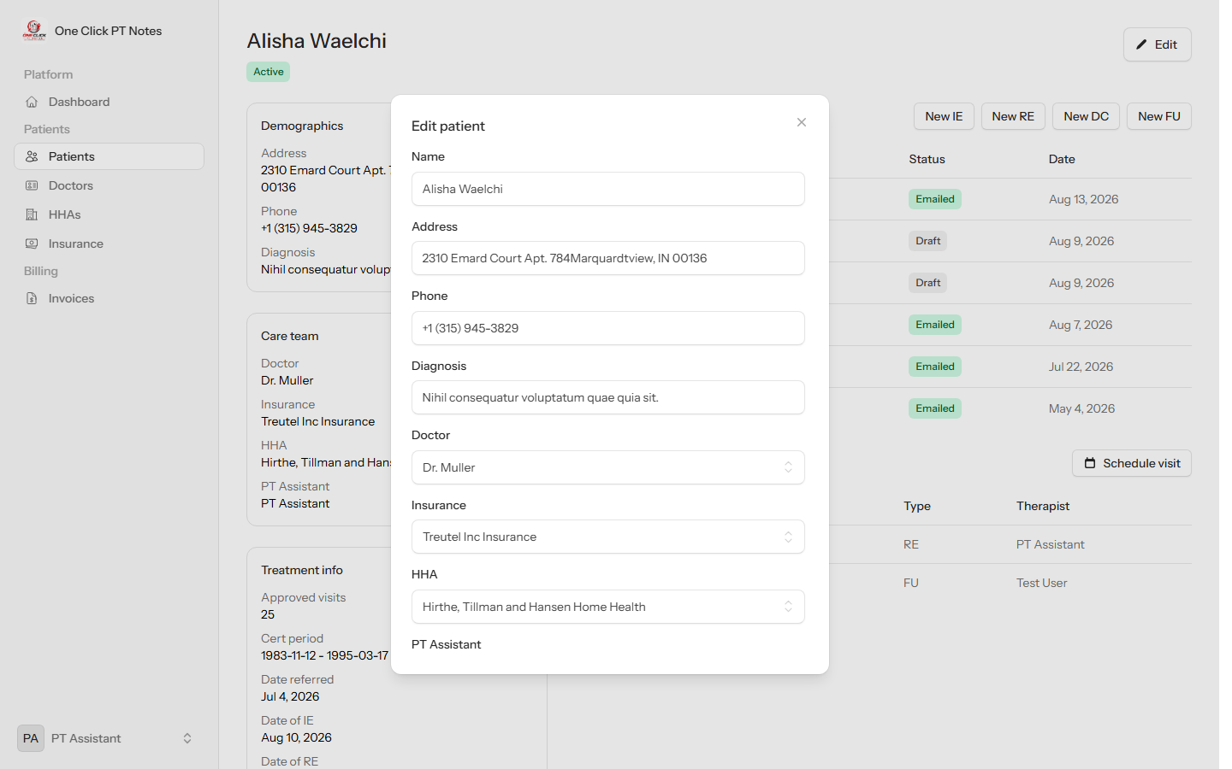
Editing a patient, including the PT Assistant field.

Who can do this: requires the patients.manage permission.

Scheduling a visit
“Schedule visit” on a patient's page books a date/time and visit type (IE, RE, DC, or FU). The logged-in user is recorded as the visit's therapist.
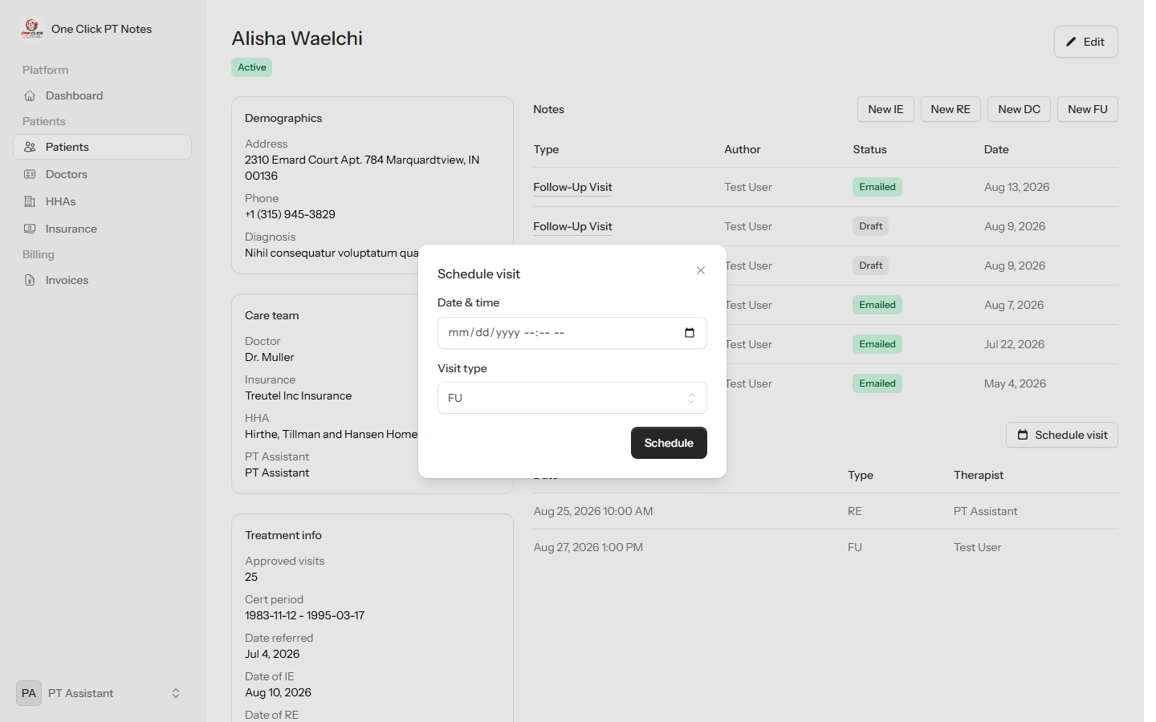
Scheduling a visit.

3. Clinical Notes & Signatures
After a visit, the visiting staff member documents it as a clinical Note. Notes come in four types — Initial Evaluation (IE), Re-Evaluation (RE), Discharge (DC), and Follow-Up (FU) — and later note types are pre-filled from the most recent earlier note, so most of the form is usually just a quick review.

Filling out the note
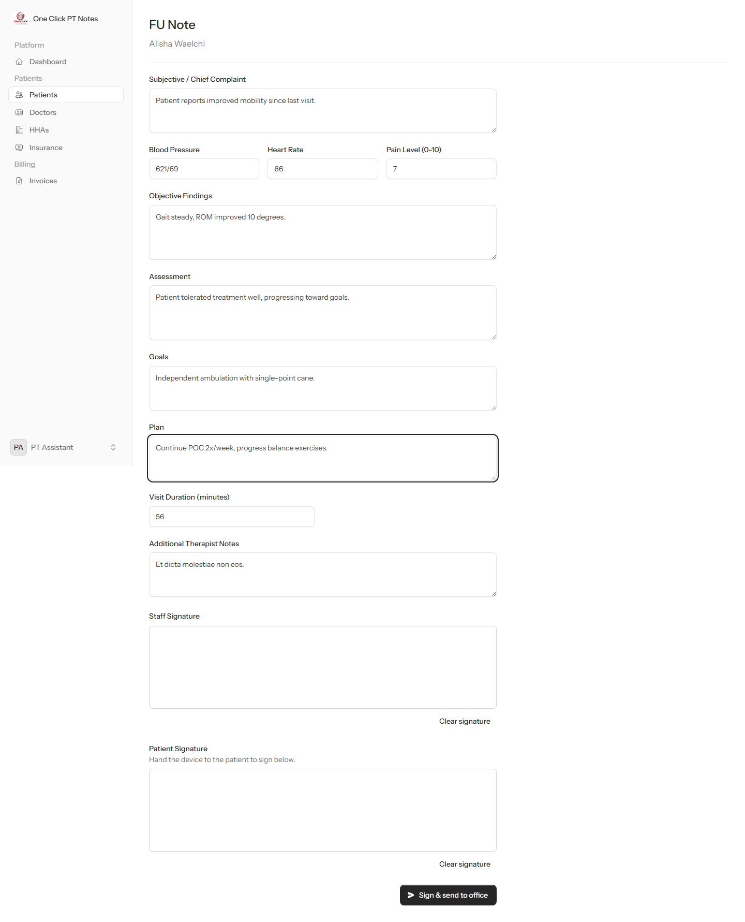
A Follow-Up note, filled out.

Two signatures required
Before a note can be sent, it needs two signatures captured right on the form: the staff member who performed the visit signs first, then hands the device to the patient to sign below. Both are required — a note with either signature missing cannot be submitted.
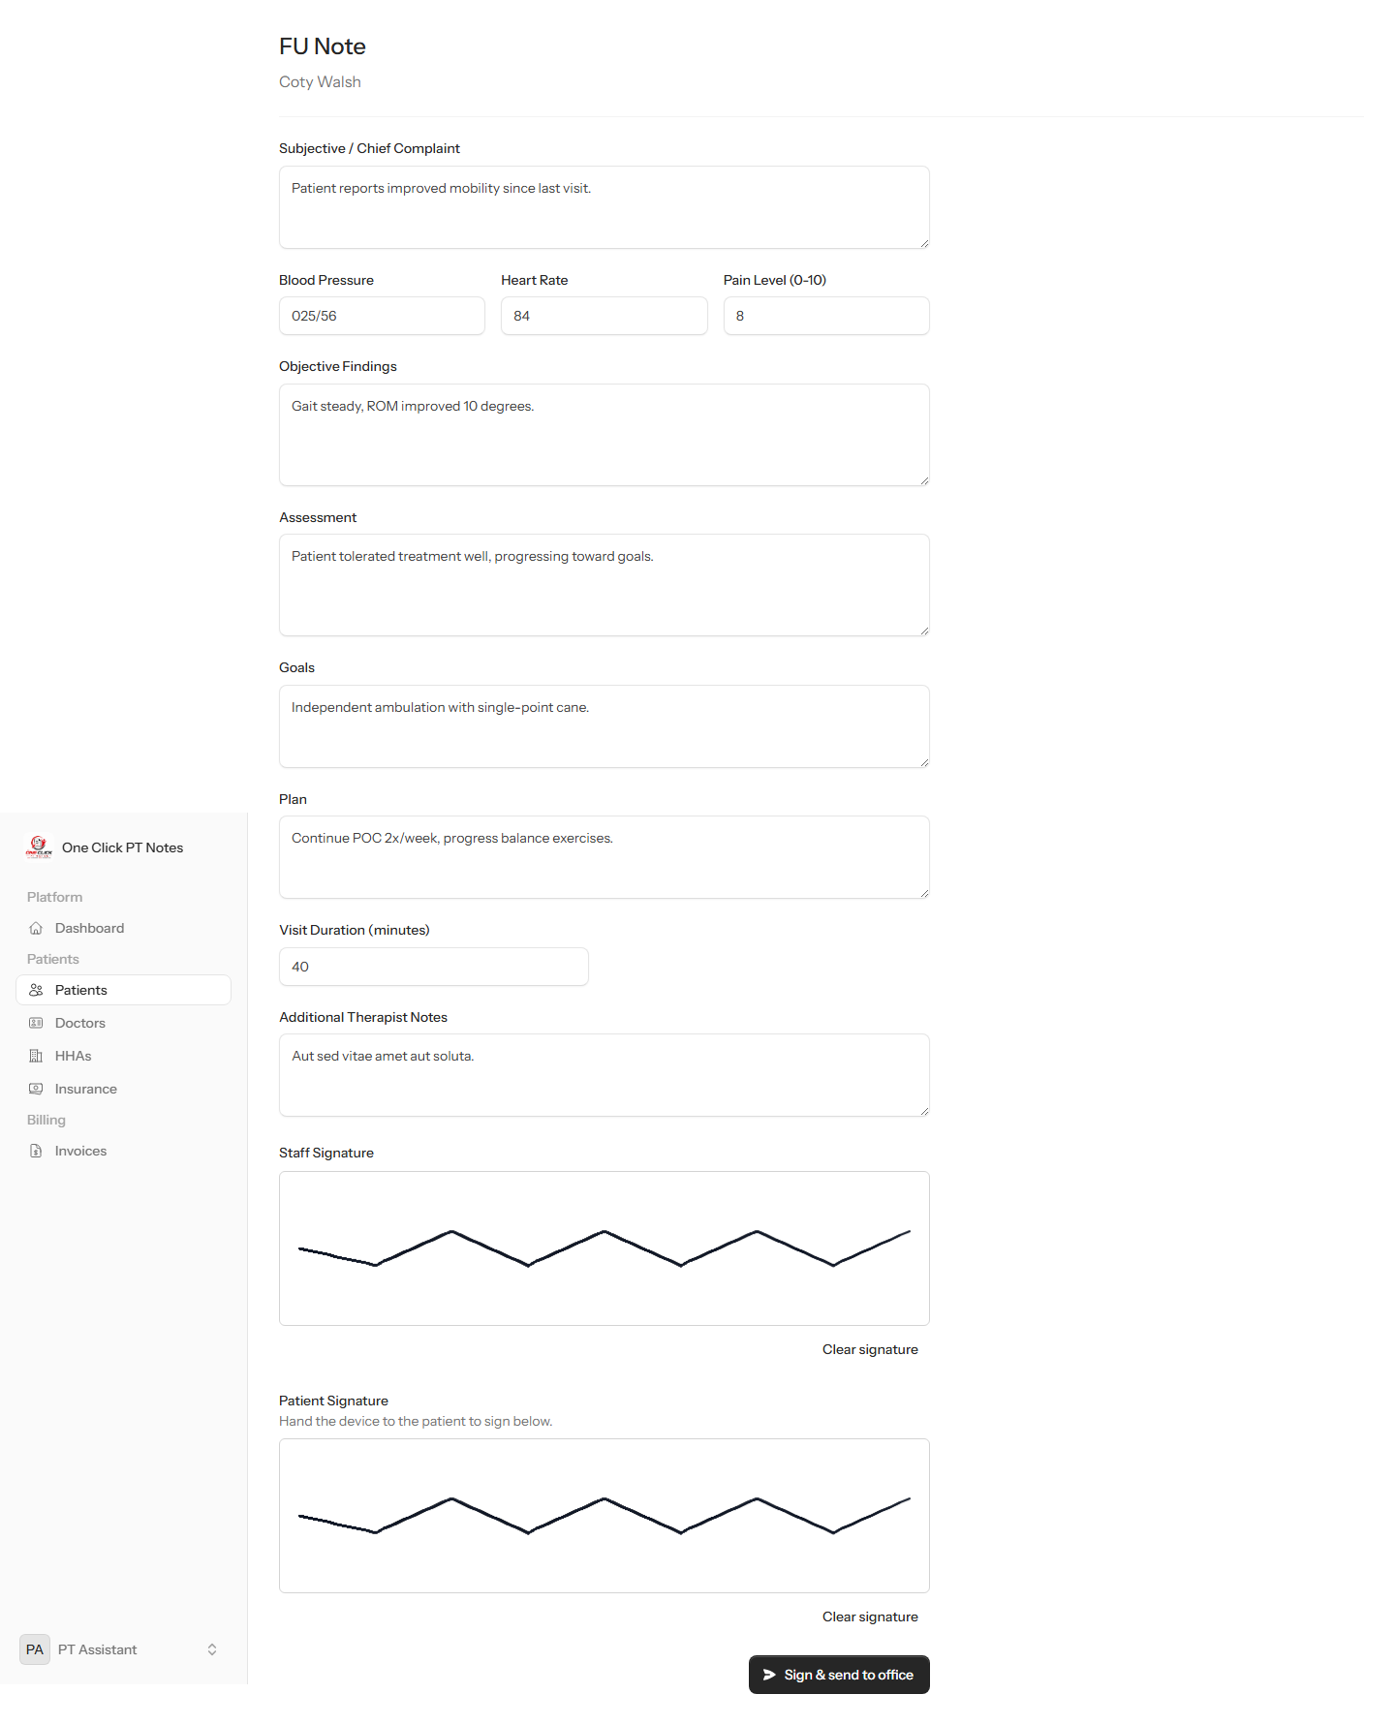
Both signatures captured, ready to submit.

After signing: PDF and office notification
Submitting the note immediately renders it to a PDF (with both signatures embedded) and emails it to the office. The note's detail page shows both signatures with who signed and when, and offers Download PDF, Resend to office, and Delete.
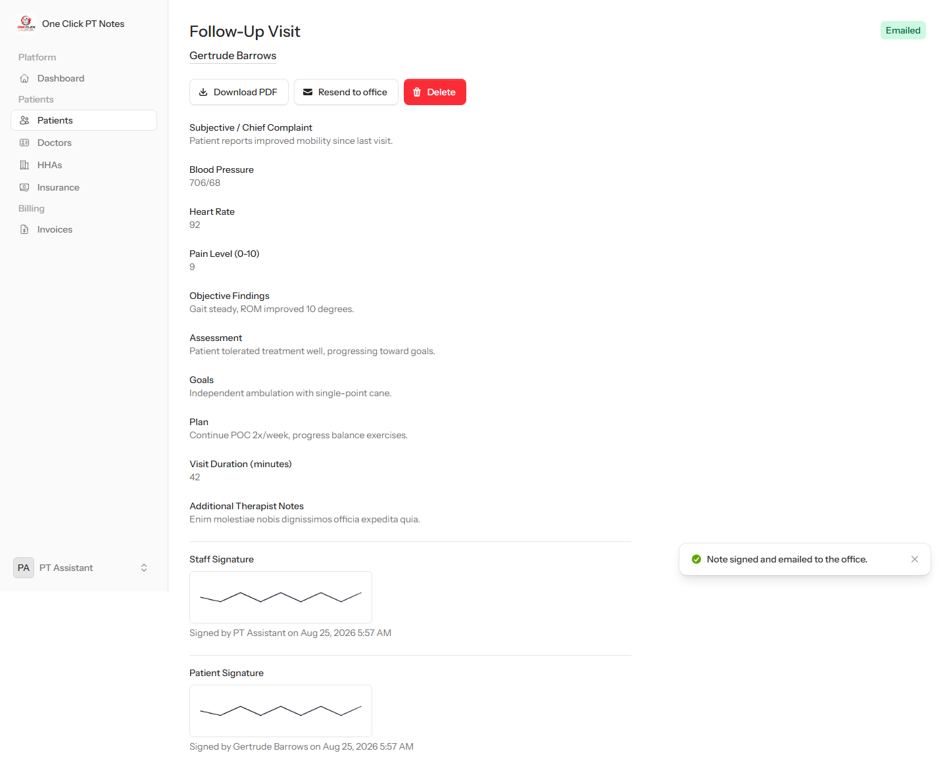
The completed, signed, and emailed note.

4. Weekly Invoicing (Billing)
At the end of the week, a PT Assistant bills a Home Health Agency for the visits performed that week. One invoice covers one agency for one Monday–Sunday week.
Who can do this: Billing → Invoices requires the invoices.manage permission (admin, Biller, Office Manager, and PT Assistant have it by default).

The invoices list
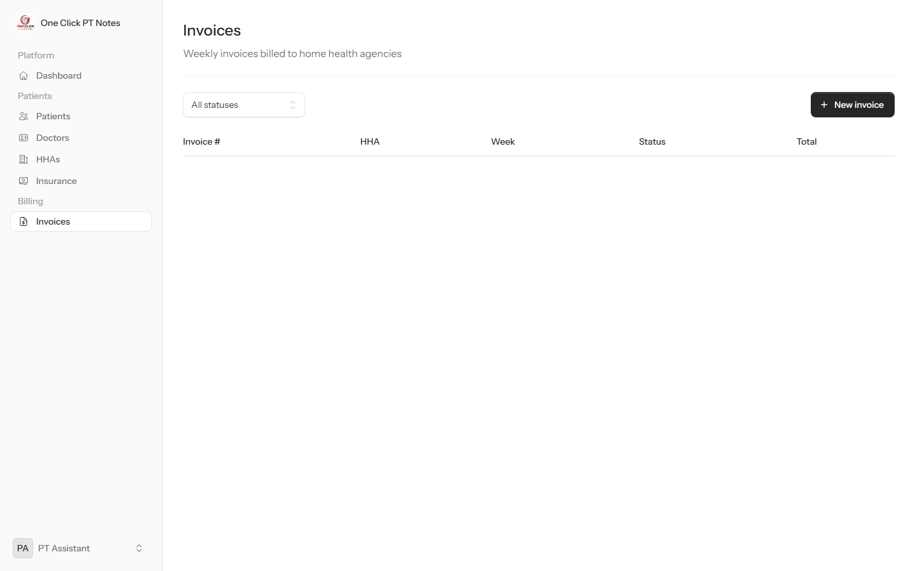
Invoices list (empty, before the first invoice is created).

Building an invoice
“New invoice” starts with picking a Home Health Agency and a week. The billing week is always shown as the full Monday–Sunday range for whatever date is picked.
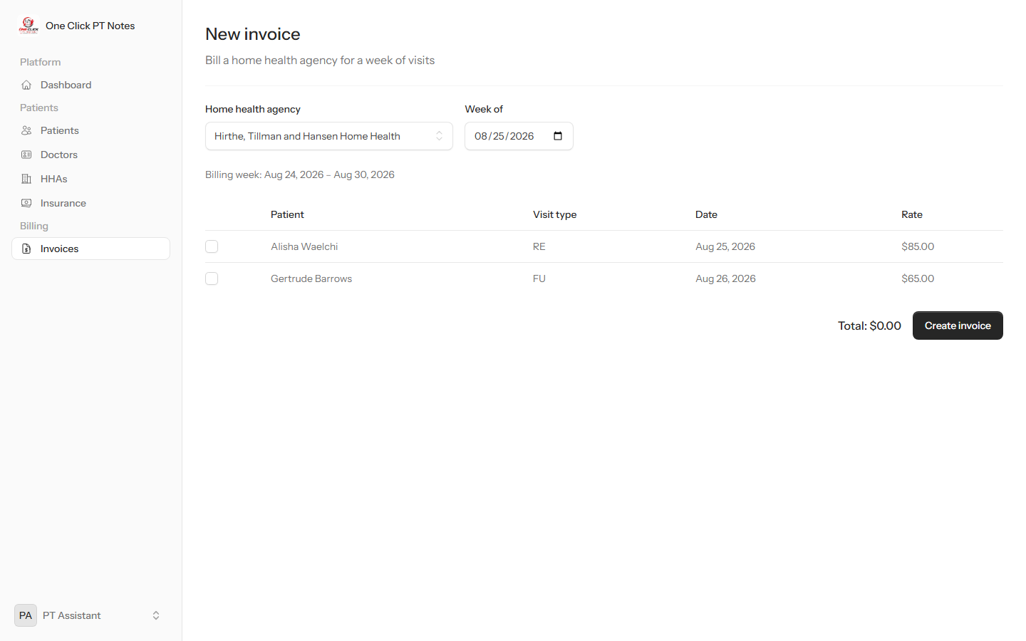
Choosing the agency and week.

Only the logged-in PT Assistant's own visits for that agency's patients during that week are listed — and only if they haven't already been billed on another invoice. Checking visits updates the running total live, using the configured rate for each visit type.
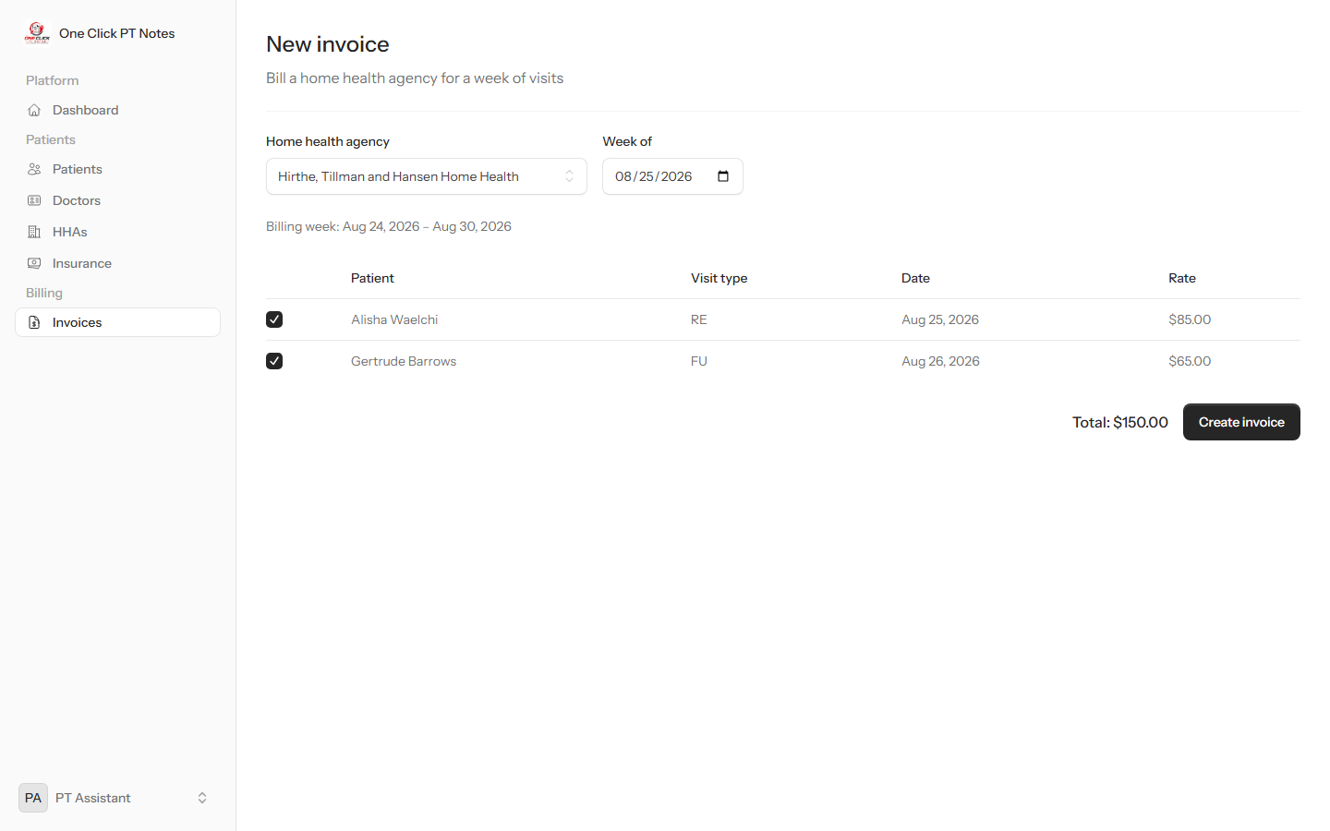
Visits selected, with the total calculated.

The invoice
A new invoice starts in Draft status with a generated invoice number, a PDF, and a line-item breakdown. From here it can be downloaded, marked Sent, and — once payment is received — marked Paid. A draft invoice can still be deleted, which frees its visits up to appear on a future invoice.
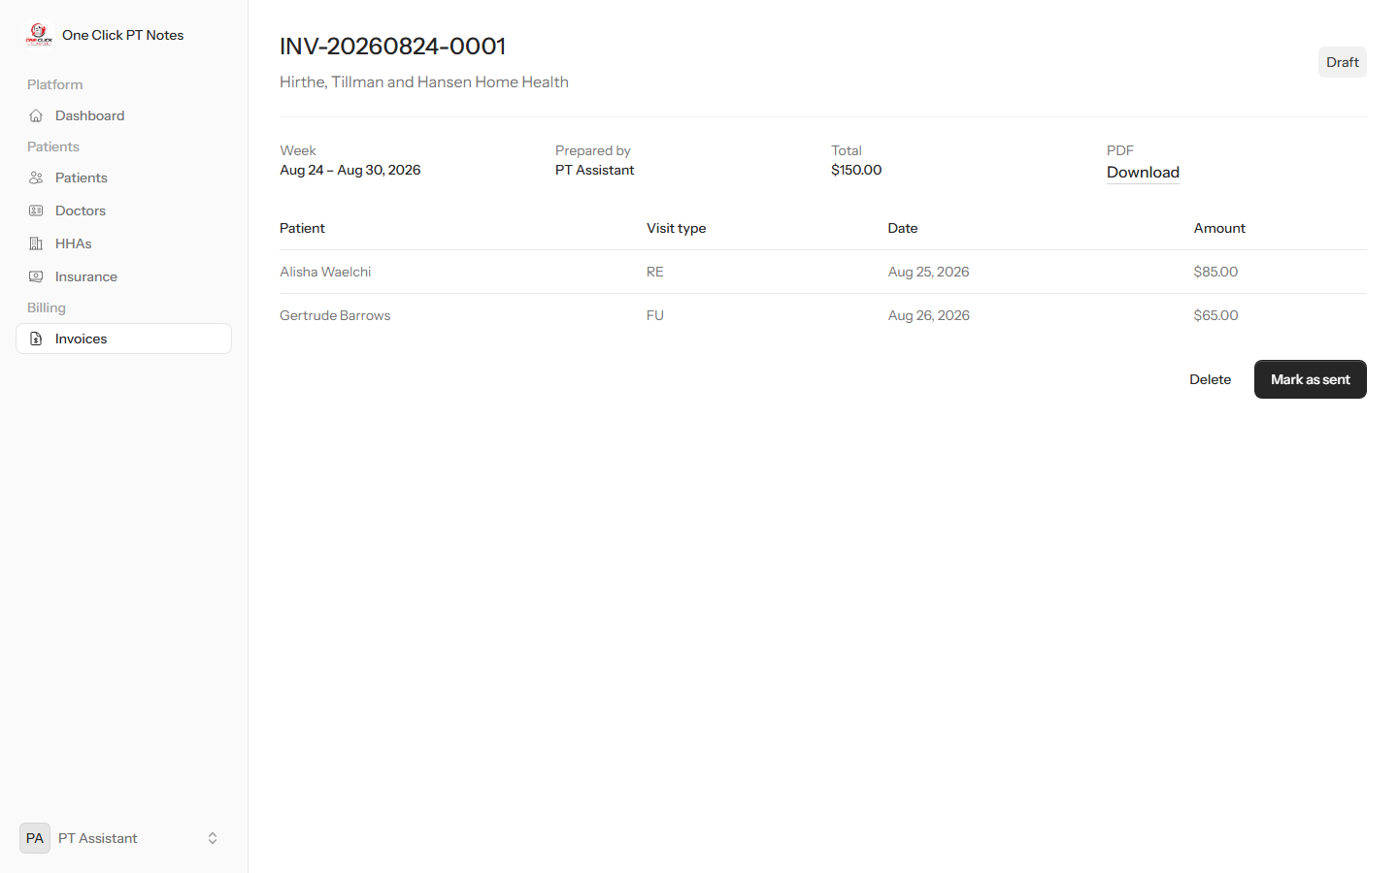
A freshly created invoice, in Draft status.

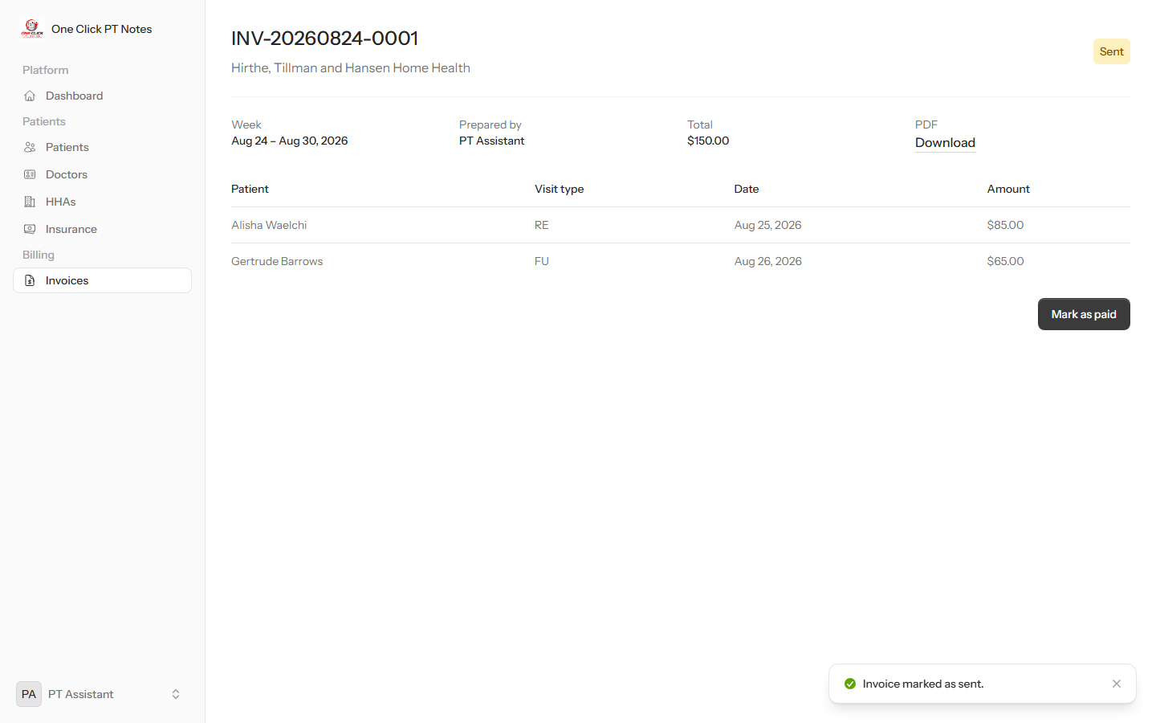
The same invoice after being marked Sent.

5. Administration
Who can do this: The entire Administration section is admin-only.

Users & roles
Admin → Users lists every account and its assigned role(s). “Edit roles” changes what a person can access without touching their login credentials.
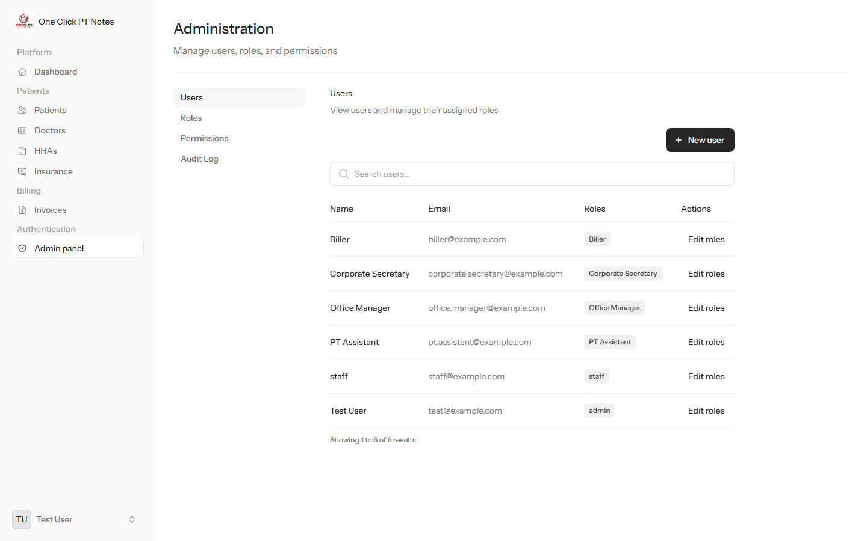
The Users list.

Roles & permissions
Admin → Roles is where roles are created and their permission sets are defined. The built-in admin and user roles can't be deleted; any other role — including custom ones like Biller or Office Manager — can be edited or removed.
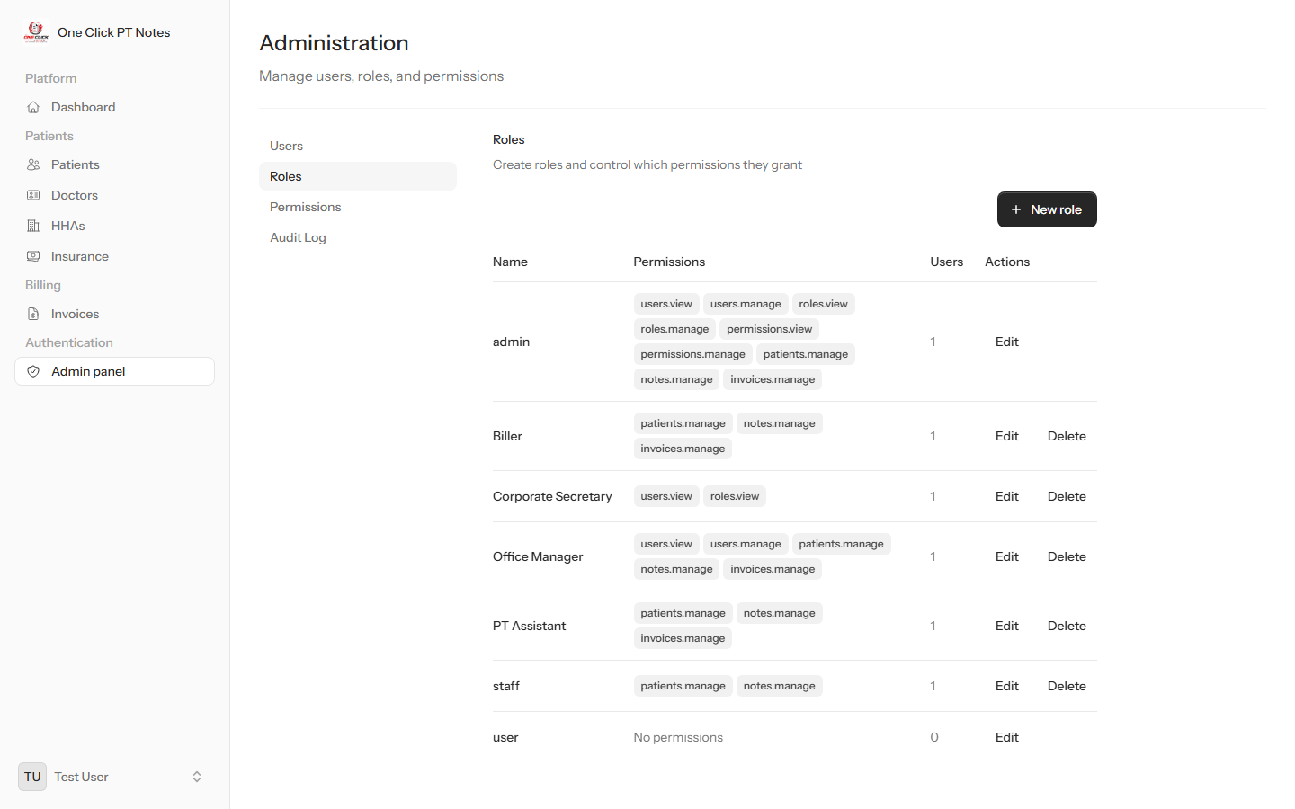
The Roles list, showing every permission each role grants.

Admin → Permissions is the underlying catalog of individual permissions (e.g. patients.manage, invoices.manage) that roles are built from, plus how many roles currently use each one.
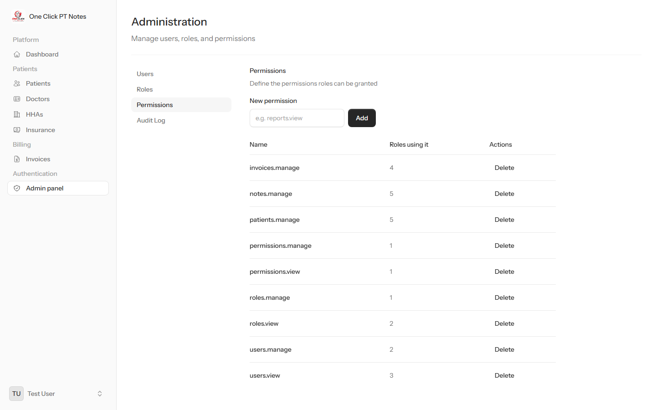
The Permissions catalog.

Audit log
Admin → Audit Log records who changed what, and when — patients, visits, notes, invoices, roles, and permission changes are all tracked automatically.
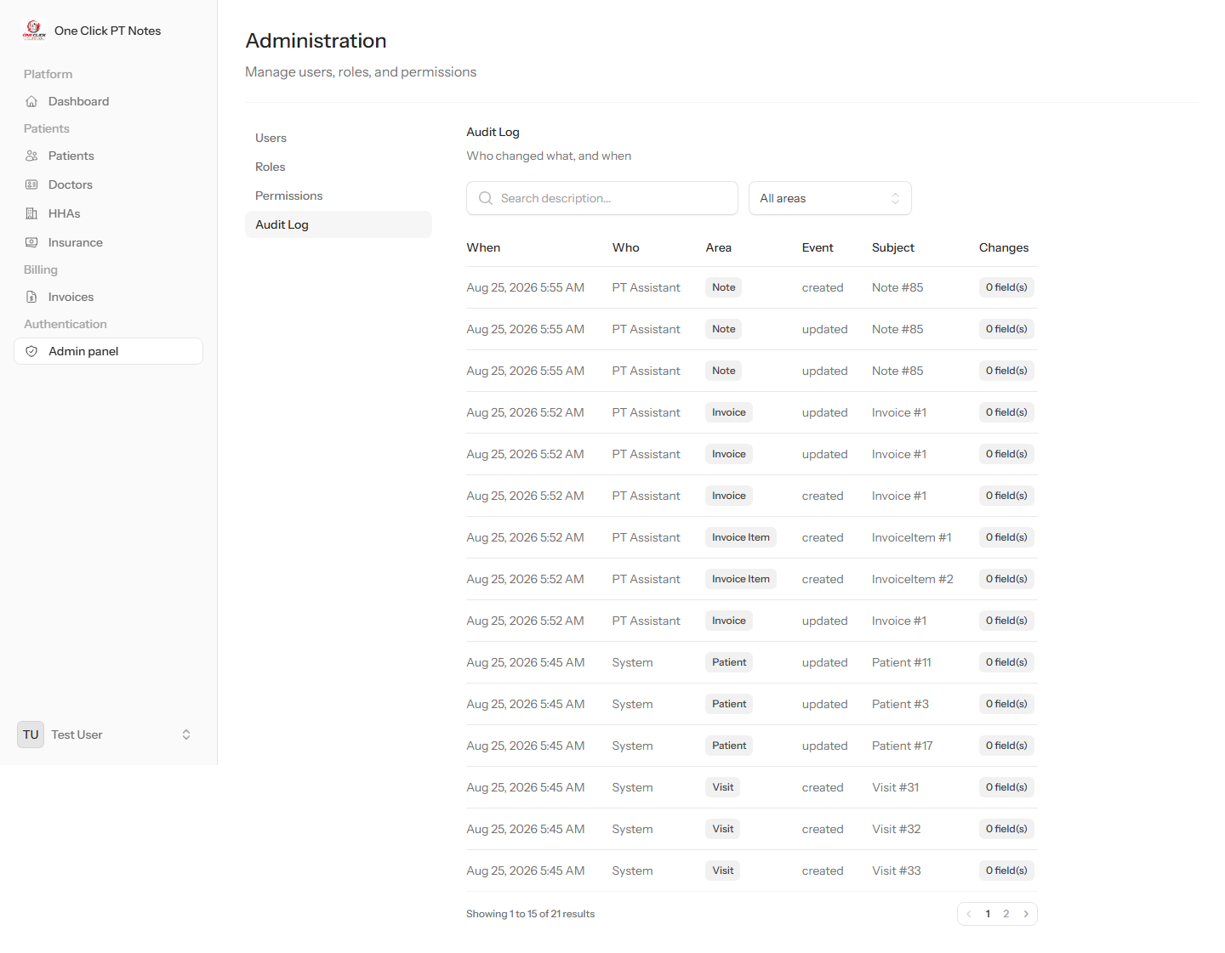
The audit log.

6. Reference Data
Doctors, Home Health Agencies, and Insurance companies are simple reference lists used throughout the app — for example, when assigning a patient's care team. Each has its own page under the Patients section for adding, editing, and removing entries.
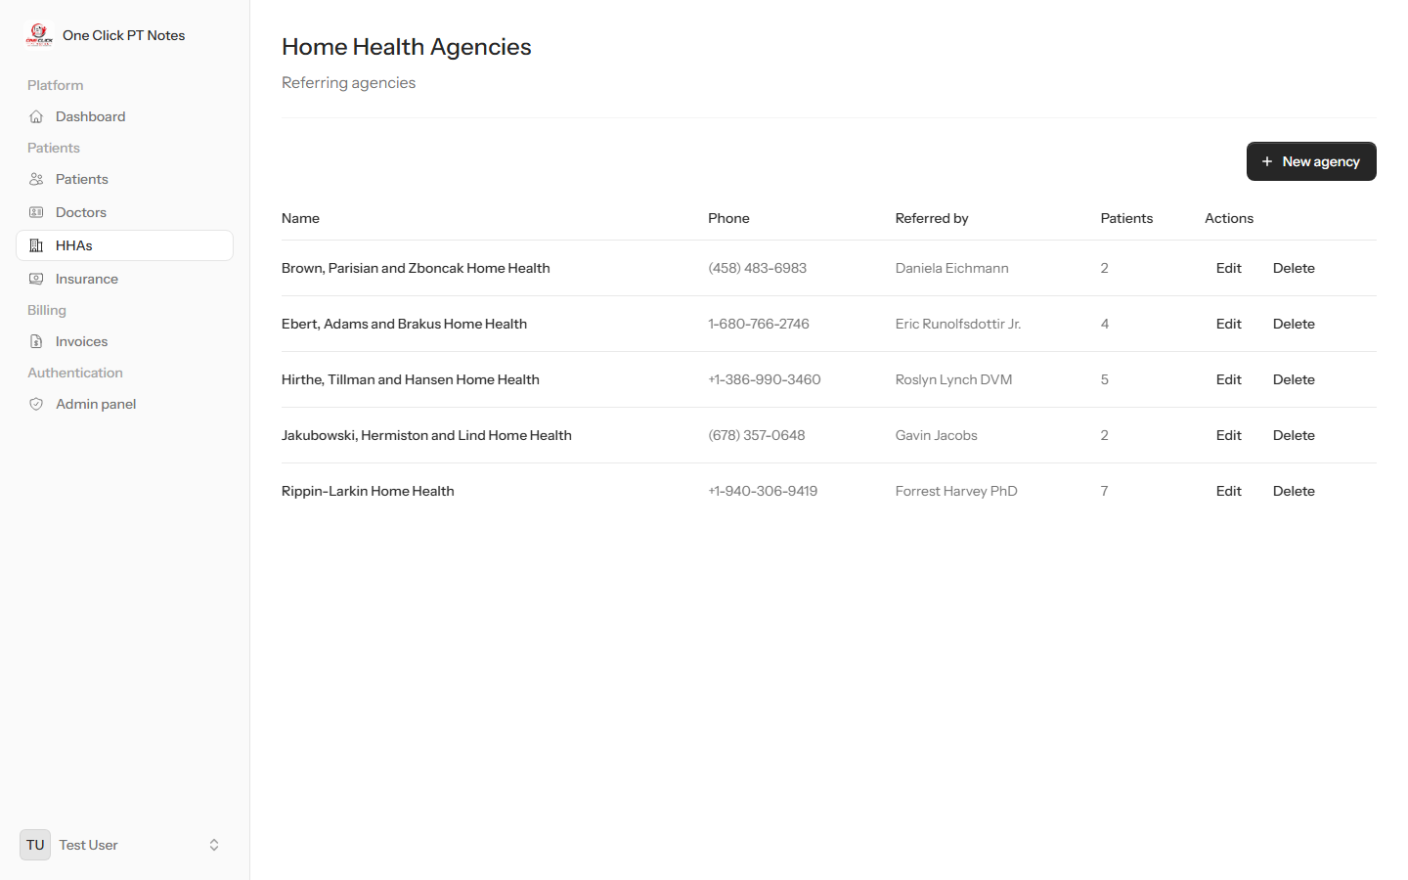
Home Health Agencies.

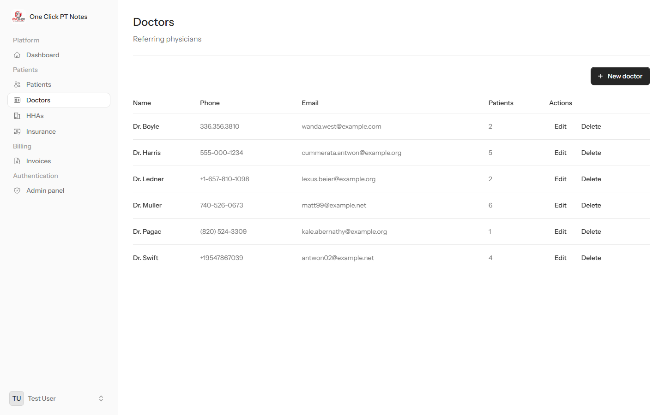
Doctors.

Appendix: Roles Quick Reference
What each built-in role can access. Permissions are additive — a role only grants what's listed.
Role | Access
admin | Everything — full access including Administration.
Office Manager | Patients, Notes, Invoices, and Users (view + manage).
Biller | Patients, Notes, and Invoices.
PT Assistant | Patients, Notes, and Invoices.
staff | Patients and Notes.
Corporate Secretary | View-only: Users and Roles (oversight, no editing).
user | No special permissions (base authenticated access).

Roles and their exact permission sets can always be reviewed and adjusted at Admin → Roles.

